Traveling to Golden?
http://visitgolden.com/getting-here-around/

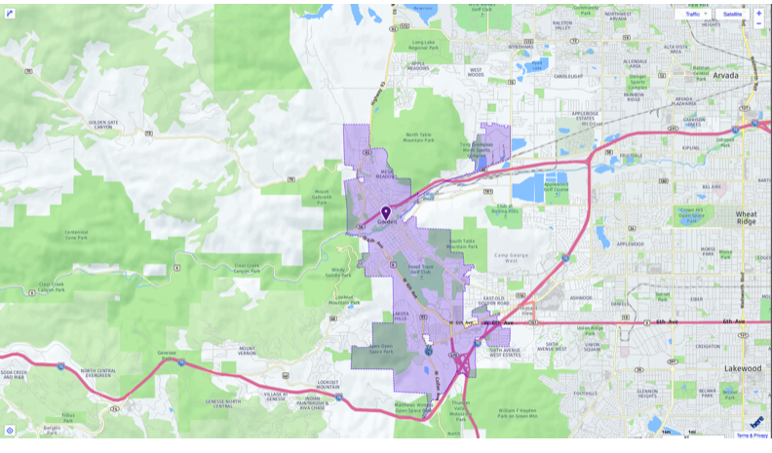
Golden can be accessed by car, trail, or rail. There are five major highways (I-70, Hwy 6, Hwy 58, Hwy 93, and C-470) that lead to Golden. No matter if you are coming from the East, West, North or South, Golden is conveniently located at the foothills of the Rockies just 20 minutes west of downtown Denver. Map your route to Golden from any starting point using Google Maps.
If you’re up for a ride, Golden can also be accessed by trail via the regional Clear Creek trail system or the C-470 Bikeway. Cyclists can also use designated bike routes on 32nd Avenue and 44th Avenue. Golden has a designated bike route on Ford Street. Remember, the rules of the road apply to cyclists!
Other Transportation
Bike rentals are available at local bike shops and the Golden Bike Library.
Visitors can also call Denver Yellow Cab at 303-777-7777 or use Uber or Lyft apps to get around.
The West Rail Line (light rail service)
Visitors to Golden can travel from downtown Denver and DIA to Golden via the West Rail Line or “W” line. The West Rail Line between Golden and Denver Union Station passes through 3 fare zones, so the price for a single, one way ticket between Golden and Denver is currently $4.00. The one-way fare from the airport is $9.00. Student and senior discounts are available, as well as day-use and multi-day passes.
Transfers are provided when requested. Transfers can be used between the light rail and bus service. If you travel from Denver to Golden on the light rail, a transfer will allow you to continue your journey into Golden via shuttle for no additional cost. The same applies if you start on a bus and transfer to the light rail. Bikes are also allowed on the light rail in designated cars.
Once you arrive in Golden on the “W” line, you can either walk, bike, ride or taxi to downtown Golden depending on the time or day of the week (and the amount of energy you have left!). You can walk or bike the 6th Avenue Trail or travel through town along Johnson Road to Ford Street. The total distance is about 2.5 miles and can take up to 1 hour (it’s hilly!).
Community Call-n-Ride Service & Circulator Bus
The Golden Community Call-n-Ride Bus service includes a call service and circulator bus service with regular stops. One-way bus fares, including the Community Call-n-Ride service or circulator bus, is $2.25. Discounts do apply.
The community circulator bus works similar to a regular bus service. The circulator bus makes scheduled stops along a designated loop through Golden every 15 minutes. You can catch the bus at the regularly scheduled times at any of the following stops:

- Illinois Street (CSM Campus)
- 11th & Illinois
- 10th & Washington (Parfet Park)
- 12th & Ford
- 17th & Jackson (Safeway)
- 24th & Jackson (Golden High School)
- Johnson & South Golden Road
- Johnson & 6th Ave. (Light Rail Station)

To schedule a ride on the Call-in-Ride service or to ask questions, call RTD at 303-519-9162. Please visit the RTD website to view the full Community Call-n-Ride Bus Schedule.
Travelers to Golden can access downtown Golden via the 16 or 16L “West Colfax” bus. Access the 16 bus schedule at the RTD website. The Bus is a great alternative during evening or weekend hours when the Circulator bus is not in service. The GS route provides bus service to and from Boulder.
Directions from Denver International Airport: When exiting Denver International Airport, remain on I-70 West. Take I-70 West about 35 miles to exit #265 Highway 58 (Golden/Central City sign). Stay on Highway 58 for about 5 miles to the Washington Avenue exit. Turn left on Washington Ave. The Golden Hotel will be on your right at the corner of 11th Street and Washington Avenue. Turn right on 11th Street and turn right again into the parking lot. Additional covered parking can be accessed via ramp at West end of lot.
Directions from Boulder: Highway 93 South to Highway 58. Left on Highway 58 to Washington Street. Right on Washington St. to 11th Street. Right on 11th Street. We are on the corner of 11th and Washington Avenue.
Directions from Colorado Springs: I-25 North to C-470 West. Follow C-470 West/Northwest for about 25 minutes. Exit on Hwy 6 West to Golden/Central City (Stay the left, C-470 will end at Hwy 6). Continue on Hwy 6 to 19th Street Make a right on 19th Street, go 5 blocks to Washington Avenue. Make a left on Washington Ave. This will take you into downtown Golden. When at 11th St, go left. We are the corner of 11th Street and Washington Avenue.
Directions from the Mountains: (eastbound I-70) Take I-70 East to Hwy 6 (exit 260) Turn left on Hwy 6 to 19th St. Make a right on 19th St and continue for 5 blocks until you reach Washington Ave. Make a left on Washington Ave. until you reach 11th St. Make a left on 11th St. We are on the corner of 11th St. and Washington Ave.
Airport Transportation
Taxi Service:
Metro Cab: 303-333-3333
Yellow Cab: 303-777-7777
Freedom Cab: 303-444-4444

Bus Service: RTD 303-299-6000
Super Shuttle: 1-800-258-3826
Denver Limousine: Reservations Airport Service 303-803-7363

